MySql Data Modeling Tutorial

(creating foreign keys using the data modeling tool)

Contents

1. Overview 2
2. Connect to Your Database 2
3. Check Your Customer and Product Table Design 3
4. Create a Data Model from your Database (called “Reverse Engineering”) 4
5. Add Associative Table (Purchase) using the Data Model Tool 7
6. Create “Many to Many” Relationship using the Data Model Tool 8
a. Create a one-to-many Relationship (one Customer can make many Purchases) 8
b. Create a one-to-many Relationship (one Product can be Purchased many times) 11
c. Rename the New Foreign Key Fields in the Purchase Table 11
7. Synchronize Data Model to the Database 12
8. Confirm that Synchronization from the Data Model Worked 14
9. Add Data to your Associative Table (Purchase) 15
10. Troubleshooting (Foreign Keys) 16
11. Reviewing Single Table Select Statement 17
12. Select Data from all Three Tables (SQL JOIN) 17
13. Summary 20

Overview
In a previous tutorial, you created and populated data into two tables (customer and product) in a MySql database schema using MySqlWorkbench. In this tutorial, you will reverse engineer a data model from that schema.
”Reverse engineering” (generally) means creating a plan from an existing implementation, whereas “forward engineering” (more common) means making a plan first and then implementing from that plan. When you “reverse engineer” a database, it means you are creating a data model (picture of the database tables and their relationships) from an existing database.
Then, from within the data modeling tool, you will add a third table (purchase) that implements a many-to-many relationship (between customer and product). You will then synchronize the data model to your database schema, effectively adding the new table into the database schema, along with foreign key constraints.
You will enter some test data into this new table (purchase) and notice how the Database Mgt System enforces primary key and foreign key constraints). Then, you will create a SQL select statement that joins data from all three of these tables.
Hopefully, you will gain an appreciation for the concept of relational database design where no redundant data is stored. Since data is only stored in one place, web applications do not have to work hard to “update all copies”. Wherever users want to see data in multiple places, your web application only needs to execute a sql join to show data that is useful and descriptive – redundant data is shown, but not stored, in the database.

Connect to Your Database
Using MySqlWorkbench, connect to the database schema that has been created for you on cis-linux2. The name of your database schema will be in this format: SP16_2308_tua12345. Instructions for how to connect to your database (and select your database as the default database) are in a separate document.

Check Your Customer and Product Table Design
Check the design of your Customer and Product table . Recall that you do this by right clicking the name of your table (in the tree view in the left “object browser” pane) and selecting “alter table”. If you do not have 3-5 records in each table, enter some test data now.
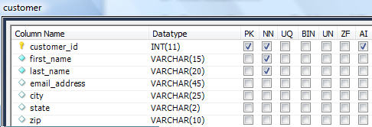
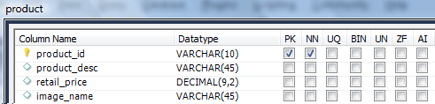
Review the Abbreviations for the checkboxes:
- PK: Primary Key (unique identifier of each record within the table)
- NN: Not Null (not allowed to be null, means it is a required field for the user to enter)
- UQ: values in this field must be unique within the table.
- AI: Auto-increment. The database management system supplies the next available number (automatically) – the user does not have to enter a value into this field.

Also, make sure each of your tables has the “InnoDB” Engine specified since we need this to support the foreign keys that we are about to add.
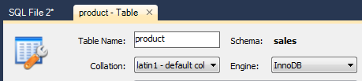

Create a Data Model from your Database (called “Reverse Engineering”)
EER Data Model means Enhanced Entity Relationship Model. Entity is another word for database table. Relationship means that records in one table point to records in another table. In the following example, there is a customer table (similar to your web_user table), a product table (similar to your “other table”), and a purchase table (similar to your “associative table”). Each purchase record will point to the customer who made the purchase and it will also point to the product being purchased. So, we will end up with 3 tables (customer, purchase, product) with 2 relationships (purchase to customer, purchase to product).

- From MySql Workbench’s menu, select “Database – Reverse Engineer”
- When the wizard starts up, select the name of your local connection or a remote connection to your database on cis-linux2. (Instructions for connecting to your database on cis-linux2 are in a separate document.)

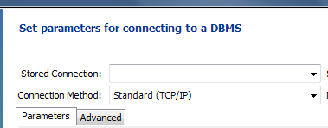

- Click next and it will connect to your database.
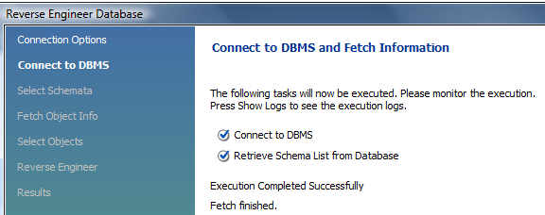

- Click next again and select your schema. Select your own database schema(named like SP14_XXXX_tua12345, where XXXX is the number of your course). PLEASE NOTE THAT IT CAN TAKE A VERY LONG TIME (to show the list of all the databases ever created by any temple student). You may have to use a CIS dept PC instead of your laptop to avoid timing out (just for this one operation).
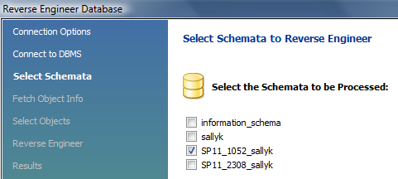
- Click next again to have it retrieve the objects from your database (your customer table and your product table):
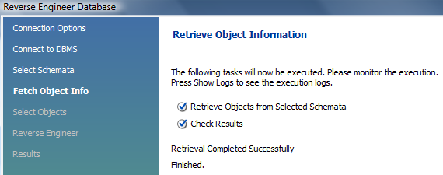

- Note that it retrieved your two tables. Click Next again to have it “Reverse Engineer”. Reverse Engineering means that a model is created from a working database. This will result in the two tables from your database being placed onto the diagram.
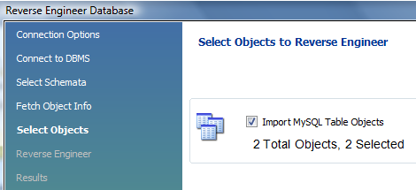

- Click next one last time so that it will display the diagram for you (with your two tables on it).
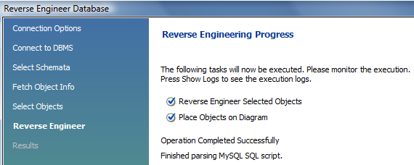

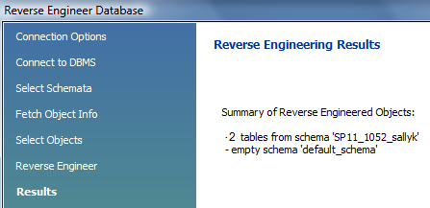

At the end of the wizard, your EERD (Enhanced Entity Relationship Datamodel) should look like this. Slide your tables so that they are not on top of each other.

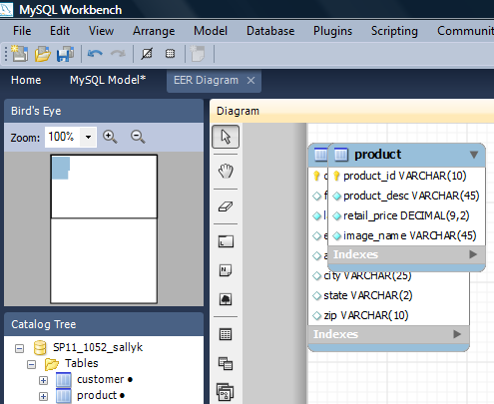

Add Associative Table (Purchase) using the Data Model Tool
You added your first two tables without using the data modeling tool, but you can also add a table within the data modeler. To do so, click on the “New Table” icon.
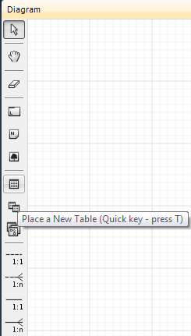
New Table
Later, we will use this “non-identifying” relationship to connect our tables.

The table that will implement a many-to-many relationship between customer and product is the purchase table. Create the purchase table using the design shown below. In a minute, we will have the data modeling tool add the Foreign Key fields (pointers) from purchase to customer and product.

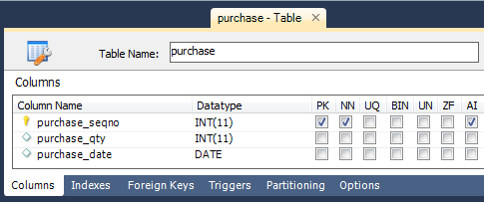

Create “Many to Many” Relationship using the Data Model Tool
In this example, we want to implement a “many to many” relationship between customer and product. (That is to say: one customer can buy many different products, one product can be purchased by many different customers.) To add a “many to many” relationship, we need to add an associative table. In this case, our associative table will be the “purchase” table and it will have a one-to-many relationship with both “customer” and “product”. If this is sounding complicated, it’s really not. Simply stated, “every record in the purchase table will indicate WHO (which customer) bought WHAT (which product)”.

Create a one-to-many Relationship (one Customer can make many Purchases)
- click on the 1:n (non identifying) relationship icon
- click on the Purchase table (the many side), then
- click on the Customer table (the one side).

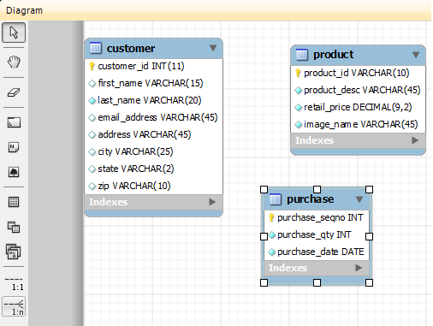
1. Click on 1:n (non-identifying) relationship
2. Click on purchase
3. Click on customer

FYI: an identifying relationship is one where the child table has a primary key that includes the parent table’s primary key. A non-identifying relationship is one where the child table’s primary key does not include the parent table’s primary key. See the example below.

Identifying Relationship Example | Non-Identifying Relationship Example
Account_table  Account_num PK  Account_name  ...  Transaction_table (has composite PK)  Account_number FK (and part of PK)  Transaction_num (part of PK)  Amount  Etc. | Account (table)  Account_num PK  Account_name  ...  Transaction (table)  Transaction_num PK  Amount  Etc.  Account_num FK

Non-identifying relationships are much more common because they are easier to use (SQL joins are less complicated) and they are more efficient (in the DBMS).

We are using the non-identifying type of primary key in this tutorial.
Once you have created the non-identifying one-to-many relationship from purchase to customer, you should see
- a “one- to-many” relationship was created between customer and purchase, as indicated by the line between these two tables. The “crows feet” symbol (on the purchase side of the relationship) indicates the many side of the relationship (many purchases can be made by one customer).
- customer_id was added, as a foreign key, into the purchase table.

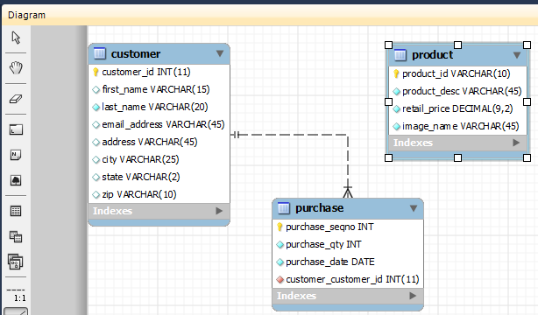
This symbol means one customer can have many purchases.
(The “crow’s feet” symbol represents the “many” side of the relationship.)

This foreign key field indicates which customer made the purchase. (We will rename it in a minute to be just “customer_id”.)

Create a one-to-many Relationship (one Product can be Purchased many times)
Using the same technique, create a non-identifying 1:n relationship between Purchase and Product. When you have done this, you should see:
- A relationship line between Purchase and Product and purchase (the crows feet indicating many on the Purchase side).
- The new Foreign Key (Product_id) added to your Purchase table.

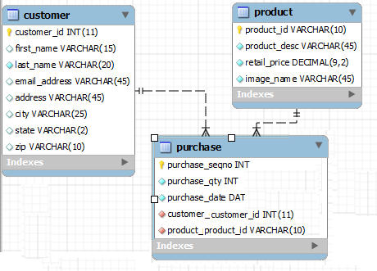
New relationship added.
New foreign key field added.

Rename the New Foreign Key Fields in the Purchase Table

This data modeling tool wants to name the Foreign Keys like “customer_customer_id” when the normal naming convention would just be “customer_id”, so let’s fix this. You can modify the table definitions right in the data modeling tool. Right click the Purchase table (as shown above), and select “Edit Table”.
- Edit the field names for the two new Foreign Key fields: rename the first Foreign Key field to be just customer_id and rename the second Foreign Key field to be just product_id.

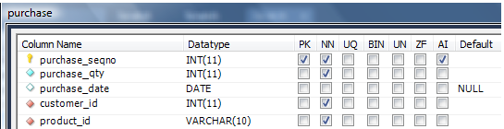
Rename “product_product_id” to “product_id”
Rename “customer_customer_id” to “customer_id”

Synchronize Data Model to the Database
With some data modeling tools, you’d be done now – creating the table and relationships from within the data model would have directly modified the database. However, with MySqlWorkbench, you need to “synchronize the data model with the database”.
- From the menu, select “Database” – “Synchronize Model”
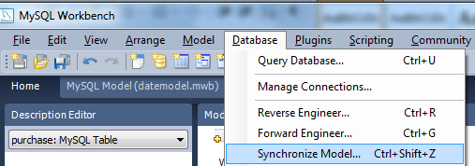
- After a few wizard screens, you should see a window that outlines the differences between your data model and your database. As you can see (below), it shows that the model has a table (purchase) that your database (“source”) does not have. Click the Update Source button (does nothing), then click Next.
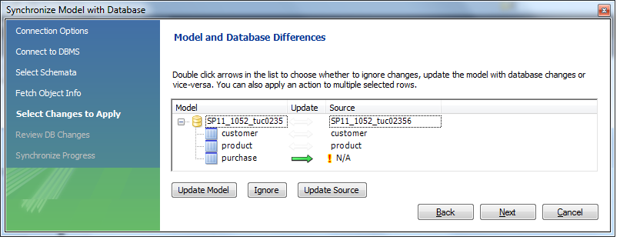
Click “Update Source” (UI gives no response)
Click Next
Then, you’ll see the SQL code to create the purchase table (specifies the Primary Key and Foreign Keys as well).
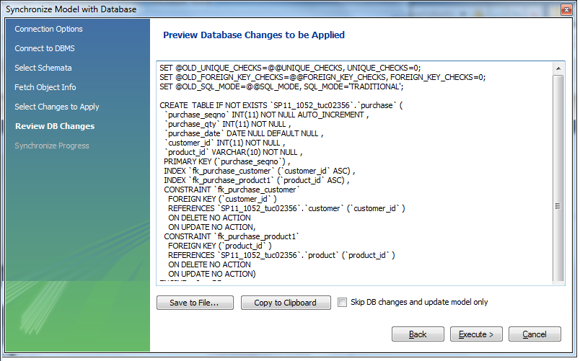
SQL that creates a new table (Purchase) and defines it’s fields.
This SQL specifies Purchase. product_id as a Foreign Key to Product.product_id.
This SQL (still within the definition of table Purchase) specifies Purchase.customer_id as a Foreign Key to Customer.customer_id.
Click Execute and finish out the rest of the wizard.

Confirm that Synchronization from the Data Model Worked
Back in MySqlWorkbench’s Object Browser, find your database, open up the “Tables” folder, and check to make sure that you have all 3 tables there (customer, product, AND purchase). You may have to right click “Tables” and select “Refresh All”.
Check that you have the new associative table (e.g., “purchase”).
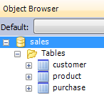
If things did not work properly, check that the new purchase table has the “InnoDB” database engine specified (right click on the the table and select “alter table”). THIS IS IMPERATIVE on cis-linux2 where the default database engine is NOT “InnoDB”. Foreign keys will not work unless you change to this engine on every table.
Next, check to see the new Foreign Key (FK) fields that were added (a pointer to a web user record, and a pointer to a record in your other table).
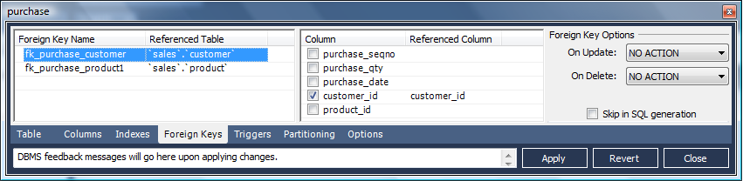

Add Data to your Associative Table (Purchase)
Now that you have successfully placed Foreign Key constraints to the associative table (purchase table) in your database, the database management system (MySql) will not allow anyone to enter a record into that associative table unless it’s Foreign Keys point to valid (existing) records in the other tables. In the example above, this means no one can enter a purchase record unless the purchase.customer_id has a value that matches some customer_id in the customer table (and purchase.product_id matches some product_id in the product table).
Check to see what Primary Key (PK) values you have now in customer.customer_id and in product.product_id. These are the only values you are allowed to enter into the Foreign Key (FK) fields customer.customer_id and product.customer_id (in your associative table, purchase). Using MySqlWorkBench, try to enter a row into your associative table.
- First enter a record that has two valid FK values (a valid customer_id and a valid product_id), click the green arrow to apply the changes. See if it lets you insert the record (it should).
- NOTE: you must enter dates in this format: YYYY-MM-DD
- Next, try to add a record with a bad value for customer ID. Try to apply the changes and it should give you an error message, specifying a Foreign Key (FK) error that mentions your customer table.
- Next, try to add a record with a bad value for product id. When you try to apply the changes, it should give you an error message, specifying a Foreign Key (FK) error that mentions your product table.
Add 8-10 records into your associative table (purchase). To help you better understand what the associative table does, make sure to add more than one associative record for some customer and make sure to add more than one associative record for some product.
FYI: for some data models, it is desirable to allow certain Foreign Key (FK) fields to hold a null value. For example, a null value in student.major_id would represent a student who has not declared a major yet. Once you start allowing null values for foreign keys, you have to learn about “outer join” select statements. With an inner join, you can select all students along with their major – including those students who have null for major_id. If you do not use an “outer join”, your select statement will only show the students who have declared a major. This tutorial does not go into optional foreign key fields and it does not cover “outer join”, but it is an important topic and one that you should learn before going out to interview for a job.

Troubleshooting (Foreign Keys)
If you need to delete a Foreign Key constraint, you can
- right click on your purchase table and select "alter table" then click on the "Foreign Keys" tab
- select one or both Foreign Keys, then right click and select “delete”
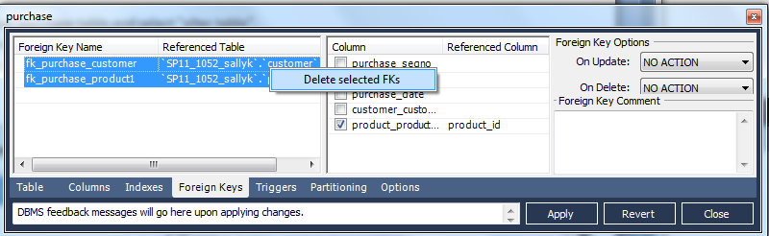
1. click on Foreign Keys tab
2. highlight then right click and delete the Foreign Keys.
Then, you can retry the exercise.

Reviewing Single Table Select Statement
Recall that if you want to show all of the columns and all the rows of a table (where order does not matter), you can simply run this query (type the SQL command into the query window at the top and then click the lightning/execute icon):
SELECT * FROM table_name;
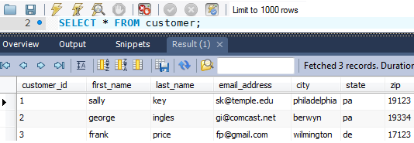
If you want to show only certain columns and selected rows and specify a desired order, you can create a SQL select statement like this. The WHERE clause restricts which rows are shown.
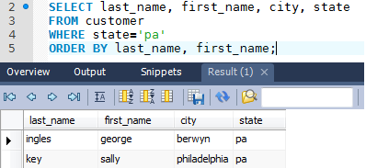

Select Data from all Three Tables (SQL JOIN)
The real power of a relational database is the ability to join data from related tables. Recall that two tables are “related” to each other if one has a foreign key that “points to” the primary keys in the other table. Your web application users will want to see more than just product IDs and customer IDs when they look at the purchase data. They will want to see the description and price of the product, and the name and address of the customer who purchased it. This is accomplished using a SQL join.
If the database has this data in it:
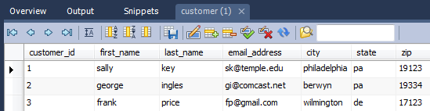
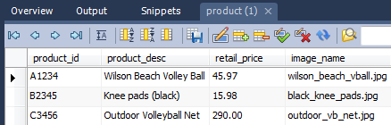
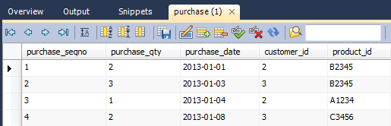
Then to join the data from these 3 tables, you could use the following SQL select statement:
SELECT * FROM customer, purchase, product
WHERE customer.customer_id = purchase.customer_id
AND product.product_id = purchase.product_id;

And you would get this result set (there are additional columns to the right that didn’t fit in the screen capture).

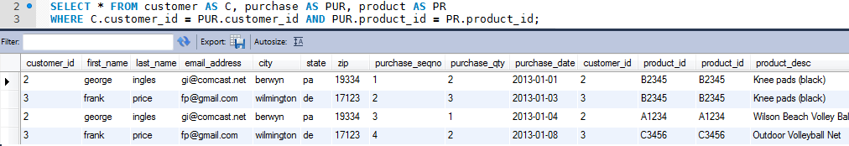
The above result set shows each purchase record along with the product that was purchased as well as the customer who bought the product. Note that wherever a column name is ambiguous (such as customer_id which exists in both the customer table as well as the purchase table), you must prefix the column name with the table name in your SQL statement.

To save on typing, you can assign table aliases as shown. For example, customer was given the alias C so that “C” can be used instead of the longer name “customer “.
SELECT * FROM customer AS C, purchase AS PU, product AS PR
WHERE C.customer_id = PU.customer_id AND PU.product_id = PR.product_id;

To understand a little better what’s going on with the join, consider a statement like “select * from customer, purchase” (where you are selecting data from two tables but did not filter out unwanted rows using the WHERE clause). You get what is called the “cross product” which is basically useless “white noise”. It shows every row in the first (customer) table along-side every row in the second (purchase) table. So, this result set is functionally useless since it shows every purchase next to every customer who may or may not have done the purchasing. Since there were 4 purchase records and 3 customers, it shows 12 rows (3*4). The first row in purchase with each of 4 customers, the second row in purchase with the same 4 customers, and so on.

SELECT * FROM customer, purchase;

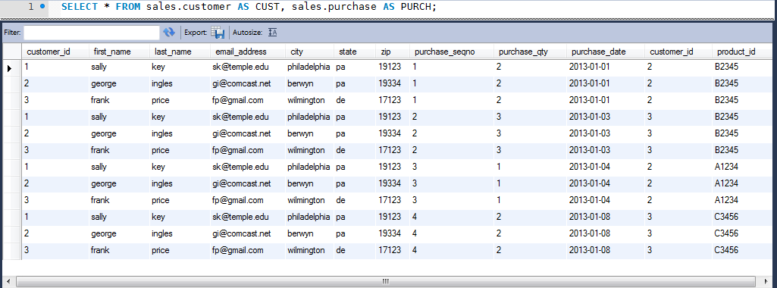

In order to make the data useful, you must restrict the select statement to ONLY display see those joined records where the purchase.customer_id matches up with a customer.customer_id (as was done initially).

Here is an example of a useful SQL SELECT statement that joins data from all 3 of your tables. This is the kind of select statement that might supply data for a page of your web application. Note the calculated columns (which are also aliased) and the ORDER BY clause which is always important when displaying information to users.

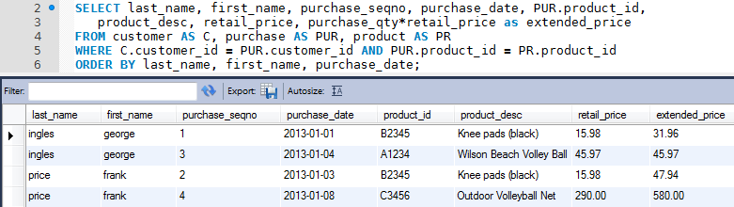

Summary
In part 1 (the previous) tutorial, you used MySqlWorkbench (GUI front end) to connect to MySql (DBMS - DataBase Management System) and create two (unrelated) database tables. You added data into these tables and executed single table SQL SELECT statements.

In part 2 (this tutorial), you used MySqlWorkbench to accomplish the following tasks.
- Created a data model by reverse engineering from your database. The model contained the tables that were already in the database (customer and product).
- Added an associative table (purchase) that implemented a many-to-many relationship between two other tables (customer and product). This was done by creating a one-to-many relationship of product to purchase (one product can have many purchases) and a one-to-many relationship of customer to purchase (one customer can have many purchases). For each relationship that was added, a Foreign Key was created. The foreign keys were: purchase.customer_id and purchase.product_id.
- By “synchronizing” from your data model to your database, the changes you made in the data modeling tool were “pushed” to your database. These changes were a new table (purchase) with two relationships (purchase to customer and purchase to product).
- To understand the concept of a foreign key constraint, you tried to enter a record into your associative table (purchase) that had an invalid foreign key, e.g., a purchase record with an invalid customer_id, a purchase record with an invalid_product_id. You found that the DBMS rejected a purchase record if there was no matching customer_id in the customer table and/or if there was no matching product_id in the product table.
- Created a SQL select statements that joined data from all 3 related tables in your database, essentially showing the associative table (purchase) records along with descriptive attributes from its related tables (“customer” and “product”).

Hopefully, these two tutorials demonstrated the power of a relational database design where no redundant data is stored. When there is no redundant data, there can never be any inconsistencies in the data. Also, your web application will only have to update data in one place, not many places (which would be more work and create more chances for programming errors and/or inconsistencies in the data). Wherever your app needs to show redundant data you will use a Sql SELECT statement to join data from multiple related tables.

